PHASE 2 : SQL QUERIES

**Table1.csv**

**Features-** Sno, BHK type, Property Type, beds, bathroom, Balcony, Address, City, State code, Country , Landmarks

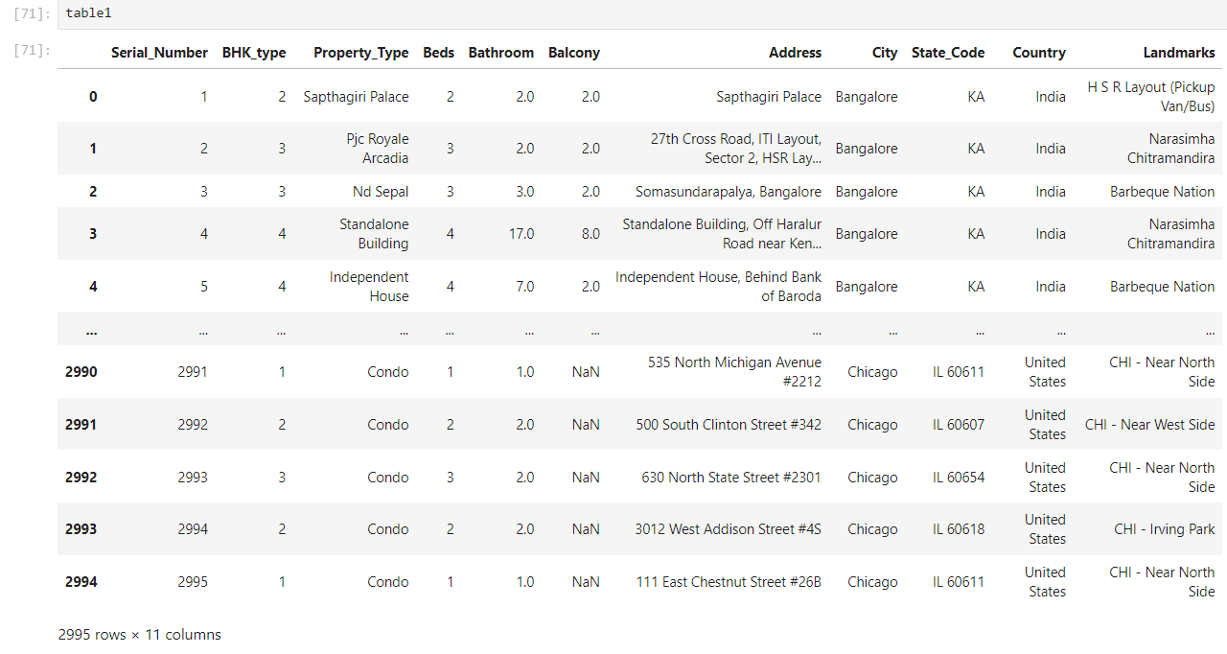

**Table2.csv**

**Features-** Sno, carpet area , status ,floor ,transaction type, Year Built, price per square feet

**Table3.csv**

**Features-** Sno , furnished status, facing , Car Parking, Type of ownership ,booking amount ,buy total price

Table1 SQL QUERIES

1. Retrieve properties with balconies, sorted by the number of bedrooms in descending order

2. Find the top 5 cities with the highest average number of bedrooms per property

3. Count the number of properties in each city.

4. Retrieve all properties with at least 3 bedrooms and 2 bathrooms.

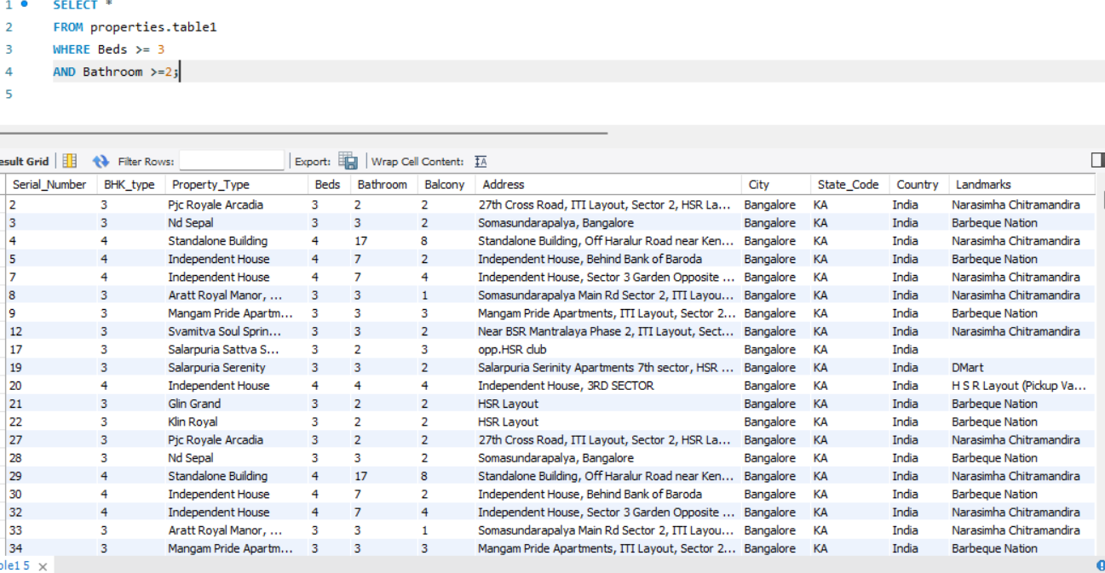

5. Find properties in a specific state with a certain landmark. (take state and landmark on your own )

Table2 SQL QUERIES

1. Calculate the average price per square foot for properties built before 2010

2. Find the total number of properties on each floor.

3. Retrieve properties with a carpet area greater than 1000 square feet and a status of 'Under Construction'

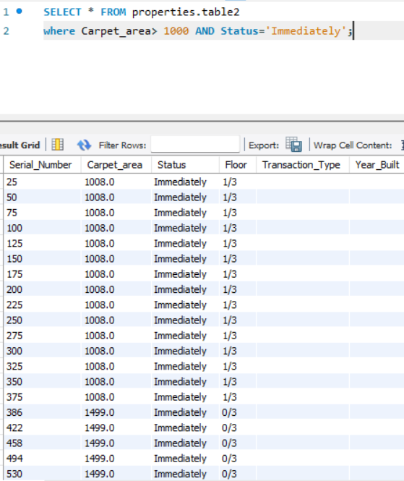

There was no property with a status of 'Under Construction' so found results with ‘Immediately’.

4. Calculate the average price per square foot for each transaction type

5. Find the properties with the highest price per square foot, sorted in descending order

Table3 SQL QUERIES

1. Retrieve all properties with a furnished status of 'Fully Furnished' and a facing direction of 'East'.

1. Calculate the average booking amount for properties with and without car parking

3. Find the total price of properties with different types of ownership.

4. Retrieve properties with a booking amount greater than 50000 and a furnished status of 'Semi Furnished

5. Find the property with the highest booking amount.

JOIN SQL Queries using all 3 tables

1. Retrieve properties from table1 that have a higher price per square foot than the average price per square foot in table 2

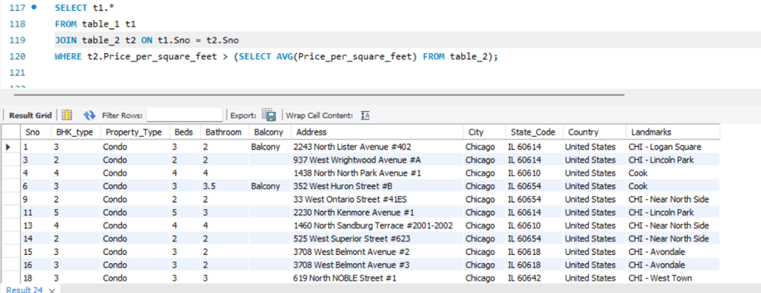

2. Find the properties in table1 that are located in cities where the average price per square foot in table2 is higher than the overall price per square foot

3. Retrieve properties from table1 with a certain landmark that have a lower price per square foot than the average price per square foot for properties with the same landmark in table2. (Choose landmark on our own)

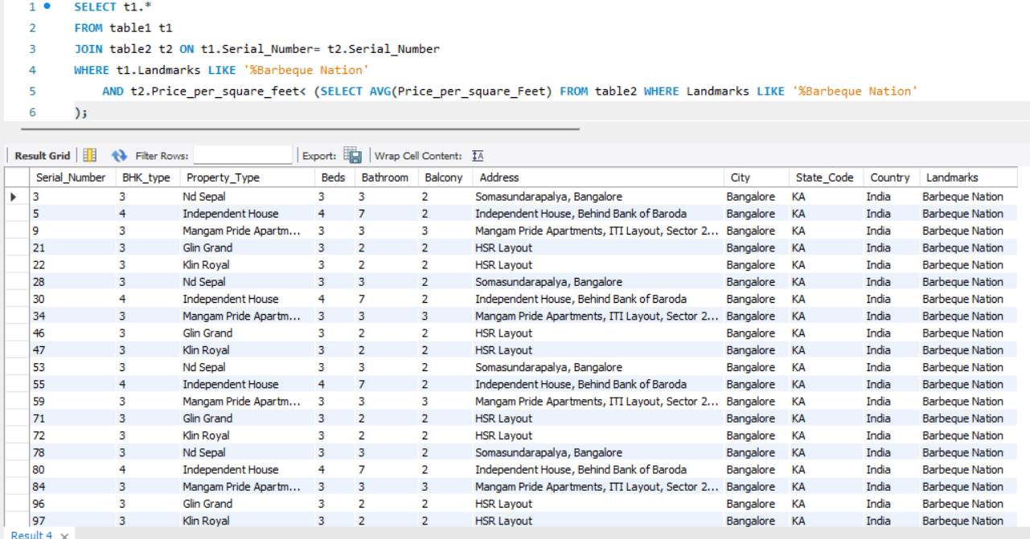

4. Retrieve properties from table2 with a price per square foot higher than the average booking amount in table3.

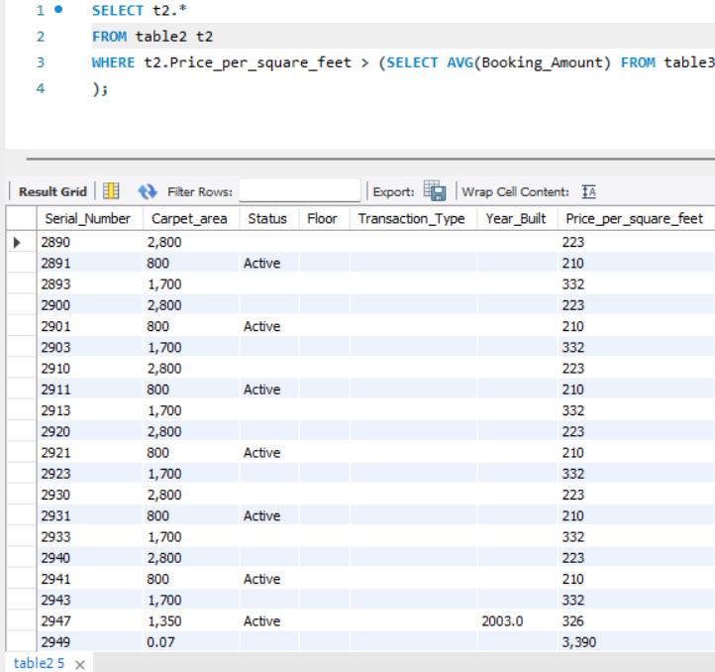

5. Count the number of properties in table2 with more bedrooms than the maximum number of bedrooms in table3.

6. Find the cities where the average booking amount in table3 is higher than the overall average booking amount, and retrieve properties from table1 located in those cities

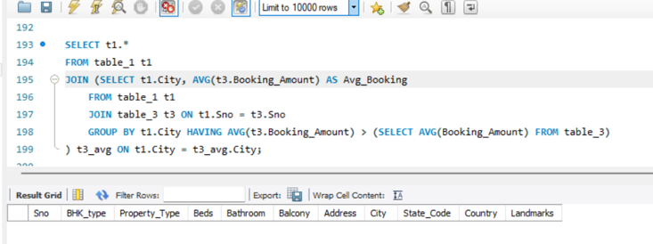

7. Retrieve properties from table1 with a furnished status of 'Unfurnished' and a facing direction that does not exist in table3.

